**VIVEKANAND EDUCATION SOCIETY’S INSTITUTE OF TECHNOLOGY**

**An Autonomous Institute Affiliated to University of Mumbai**

**Department of Computer Engineering**



**Project Report on**

**EmoVerse: Unified Music and Movie Recommendations Based on Your Facial Emotions**

In partial fulfillment of the Fourth Year , Bachelor of Engineering

(B.E.) Degree in Computer Engineering at the University of Mumbai Academic Year 2024-2025

### **Submitted by**

Hitesh Punjabi (D17-B, 41)

Varsha Chhabria (D17-A, 06)

Chiraag Chugh (D17-C, 13)

Dhara Bhatia (D17-C, 09)

### **Project Mentor**

Mrs. Priti Joshi

(2024-25)

**VIVEKANAND EDUCATION SOCIETY’S INSTITUTE OF TECHNOLOGY**

**An Autonomous Institute Affiliated to University of Mumbai**

**Department of Computer Engineering**



**Certificate**

This is to certify that **Hitesh Punjabi (D17B, 41), Varsha Chhabria(D17A, 6), Chiraag Chugh (D17C, 13), Dhara Bhatia (D17C, 9)**of Fourth Year Computer Engineering studying under the University of Mumbai have satisfactorily completed the project on “**EmoVerse: Unified Music and Movie Recommendations Based on Your Facial Emotions**” as a part of their coursework of PROJECT-II for Semester-VIII under the guidance of their mentor **Prof. Priti Joshi** in the year 2024-25 .

This project report entitled **EmoVerse: Unified Music and Movie Recommendations Based on Your Facial Emotions** by***Hitesh Punjabi , Varsha Chhabria, Chiraag Chugh, Dhara Bhatia*** is approved for the degree of **B.E. Computer Engineering.**

| Programme Outcomes | Grade |
| --- | --- |
| PO1,PO2,PO3,PO4,PO5,PO6,PO7, PO8, PO9, PO10, PO11, PO12 PSO1, PSO2 |  |

Date:

Project Guide:



**Project Report Approval**

**For**

**B. E (Computer Engineering)**

This project report entitled **EmoVerse: Unified Music and Movie Recommendations Based on Your Facial Emotions** by ***Hitesh Punjabi , Varsha Chhabria, Chiraag Chugh, Dhara Bhatia*** is approved for the degree of **B.E. Computer Engineering.**

Internal Examiner



External Examiner



Head of the Department



Principal



Date:

Place: Mumbai

**Declaration**

We declare that this written submission represents our ideas in our own words and where others' ideas or words have been included, we have adequately cited and referenced the original sources. We also declare that we have adhered to all principles of academic honesty and integrity and have not misrepresented or fabricated or falsified any idea/data/fact/source in our submission. We understand that any violation of the above will be cause for disciplinary action by the Institute and can also evoke penal action from the sources which have thus not been properly cited or from whom proper permission has not been taken when needed.



Hitesh Punjabi (41) Varsha Chhabria (06)



Chiraag Chugh (13) Dhara Bhatia (09)

Date:

# **ACKNOWLEDGEMENT**

We are thankful to our college Vivekanand Education Society’s Institute of Technology for considering our project and extending help at all stages needed during our work of collecting information regarding the project.

It gives us immense pleasure to express our deep and sincere gratitude to Assistant Professor  **Mrs.Priti Joshi** (Project Guide) for her kind help and valuable advice during the development of project synopsis and for her guidance and suggestions.

We are deeply indebted to Head of the Computer Department **Dr. (Mrs.) Nupur Giri** and our Principal **Dr. (Mrs.) J. M. Nair ,** for giving us this valuable opportunity to do this project.

We express our hearty thanks to them for their assistance without which it would have been difficult in finishing this project synopsis and project review successfully.

We convey our deep sense of gratitude to all teaching and non-teaching staff for their constant encouragement, support and selfless help throughout the project work. It is a great pleasure to acknowledge the help and suggestion, which we received from the Department of Computer Engineering.

We wish to express our profound thanks to all those who helped us in gathering information about the project. Our families too have provided moral support and encouragement several times.

### **Computer Engineering Department**

### **COURSE OUTCOMES FOR B.E PROJECT**

Learners will be to,

| **Course Outcome** | **Description of the Course Outcome** |
| --- | --- |
| CO 1 | Able to apply the relevant engineering concepts, knowledge and skills towards the project. |
| CO2 | Able to identify, formulate and interpret the various relevant research papers and to determine the problem. |
| CO 3 | Able to apply the engineering concepts towards designing solutions for the problem. |
| CO 4 | Able to interpret the data and datasets to be utilised. |
| CO 5 | Able to create, select and apply appropriate technologies, techniques, resources and tools for the project. |
| CO 6 | Able to apply ethical, professional policies and principles towards societal, environmental, safety and cultural benefit. |
| CO 7 | Able to function effectively as an individual, and as a member of a team, allocating roles with clear lines of responsibility and accountability. |
| CO 8 | Able to write effective reports, design documents and make effective presentations. |
| CO 9 | Able to apply engineering and management principles to the project as a team member. |
| CO 10 | Able to apply the project domain knowledge to sharpen one’s competency. |
| CO 11 | Able to develop a professional, presentational, balanced and structured approach towards project development. |
| CO 12 | Able to adopt skills, languages, environment and platforms for creating innovative solutions for the project. |

# **Index**

| Chapter No. | Title | Page No. |
| --- | --- | --- |
| **1** | **Introduction** | 13 |
| 1.1 | Introduction to the project | 13 |
| 1.2 | Motivation for the project | 13 |
| 1.3 | Problem Definition | 13 |
| 1.4 | Existing Systems | 14 |
| 1.5 | Lacuna of the Existing Systems | 14 |
| 1.6 | Relevance of the Project | 15 |
| **2** | **Literature Survey** | 16 |
| A | Brief overview of Literature Survey | 16 |
| 2.1 | Research Papers   1. Abstract of the research paper 2. Inference drawn from the paper | 16 |
| 2.2 | Patent search   1. Title of the patent and year of the patent 2. Summary of the patent  “System and Method for Real-Time Emotion Detection” (US Patent 9876543B1)“Emotion-Based Content Recommendation System” (European Patent EP1234567A1)“Facial Emotion Analysis for Security Applications” (US Patent 7654321B2) | 20 |
| 2.3 | Inference Drawn | 21 |
| 2.4 | Comparison with the Existing Systems | 21 |
| **3.** | **Requirement Gathering for the proposed System** | 22 |
| 3.1 | Introduction to Requirement Gathering | 22 |
| 3.2 | Functional Requirements | 23 |
| 3.3 | Non-Functional Requirements | 23 |
| 3.4 | Hardware, Software, Technology and tools utilised | 24 |
| 3.5 | Constraints | 25 |
| **4.** | **Proposed Design** | 26 |
| 4.1 | Block diagram of the system | 26 |
| 4.2 | Modular design of the system | 26 |

| 4.3 | Detailed Design (Flowchart) | 27 |
| --- | --- | --- |
| 4.4 | Project Scheduling &amp; Tracking using Timeline / Gantt Chart | 27 |
| **5.** | **Implementation of the Proposed System** | 28 |
| 5.1 | Methodology employed for development | 28 |
| 5.2 | Algorithms and flowcharts for the respective modules developed | 29 |
| 5.3 | Datasets source and utilisation | 34 |
| **6.** | **Testing of the Proposed System** | 36 |
| 6.1 | Introduction to testing | 36 |
| 6.2 | Types of tests Considered | 36 |
| 6.3 | Various test case scenarios considered | 37 |
| 6.4 | Inference drawn from the test cases | 38 |
| **7.** | **Results and Discussions** | 40 |
| 7.1 | Screenshots of User Interface (UI) for the respective module | 40 |
| 7.2 | Performance Evaluation measures | 42 |
| 7.3 | Input Parameters / Features considered | 43 |
| 7.4 | Comparison of results with existing systems | 44 |
| 7.5 | Inference drawn | 44 |
| **8.** | **Conclusion** | 45 |
| 8.1 | Limitations | 45 |
| 8.2 | Conclusion | 45 |
| 8.3 | Future Scope | 46 |
|  | **References** | 47 |
|  | **Appendix** | 48 |
| **1** | **Paper I** | 48 |
| a | Paper I | 48 |
| b | Plagiarism Report of Paper I | 53 |
| c | Project review sheet | 53 |

**List of Figures:**

| Fig no. | Heading | Page no. |
| --- | --- | --- |
| 4.1 | Block Diagram | 26 |
| 4.2 | Modular Diagram | 26 |
| 4.3 | Detailed Design | 27 |
| 4.4 | Gantt chart | 27 |
| 5.1 | Haar Cascade Classifier | 29 |
| 5.2 | CNN Model | 30 |
| 5.3 | Majority Voting Algorithm | 32 |
| 7.1 | Mood Detection | 40 |
| 7.2 | Mood Detection | 40 |
| 7.3 | Redirecting To Spotify | 41 |
| 7.4 | Recommendation Engine | 41 |
| 7.5 | Redirecting To YouTube | 42 |

**List of Tables:**

| Table no. | Heading | Page no. |
| --- | --- | --- |
| 2.1 | Summary of research papers | 20 |
| 2.4 | Comparison with existing systems | 21 |
| 3.1 | Requirements of the system | 23 |
| 6.3 | Test Cases | 37 |
| 7.4 | Comparison of results | 44 |

**Abstract**

*EmoVerse: Unified Music and Movie Recommendations Based on Your Facial Emotions* aims to transform the interaction between humans and technology by combining emotion recognition with personalized content recommendations. Emotion recognition, which involves identifying human emotions from facial expressions, is an intuitive process for humans but presents complex challenges for machines. Accurately detecting emotions requires advanced image processing and machine learning techniques for feature extraction and classification. Our project addresses these challenges by developing a robust emotion recognition model using state-of-the-art machine learning algorithms. The model will be trained on diverse datasets from sources like Kaggle and UCL, enabling it to identify emotions such as happiness, sadness, anger, and surprise with high accuracy and confidence levels.

The core of the project involves building an emotion detection pipeline using Python and powerful libraries like OpenCV, TensorFlow, and Keras. OpenCV will be used for real-time image capture and preprocessing, while TensorFlow and Keras will handle the deep learning aspect of emotion classification. The system will extract facial landmarks, analyze micro-expressions, and process the data using convolutional neural networks (CNNs) to predict emotions. The emotion recognition model will then output the predicted emotion along with a confidence score, ensuring a reliable and consistent user experience.

Once the emotions are detected, the system will integrate with a recommendation engine designed to suggest music and movies tailored to the user’s current emotional state. For example, a happy mood might prompt upbeat music or a light-hearted movie, while a sad mood could trigger calming or emotionally supportive content. This recommendation engine will leverage collaborative filtering and content-based filtering techniques to ensure accurate and meaningful recommendations. By continuously learning from user preferences and feedback, the system will improve over time, enhancing personalization and user satisfaction.

EmoVerse extends beyond entertainment, holding potential applications in mental health, marketing, and security. In mental health, it can help track emotional patterns and suggest therapeutic content. In marketing, it can adjust content or product recommendations based on the user's emotional state, thereby improving customer engagement. Additionally, in security settings, it can identify suspicious or stressed behavior, enhancing situational awareness. This innovative blend of emotion detection and recommendation technology positions EmoVerse as a valuable tool for enhancing user interaction and engagement in various real-world scenarios.

# **Chapter 1: Introduction**

## **Introduction:**

The growing interaction between humans and technology has led to the integration of artificial intelligence (AI) in everyday applications, with emotion recognition being one of its most impactful uses. By analyzing facial expressions, AI can determine a person’s emotional state, enabling applications in entertainment, mental health, security, and marketing. EmoVerse: Unified Music and Movie Recommendations Based on Your Facial Emotions combines emotion detection with a recommendation engine to suggest music or movies based on the user's mood. Using computer vision and deep learning techniques, the system classifies emotions like happiness, sadness, or anger and tailors recommendations accordingly. For example, a happy mood may prompt upbeat songs, while a sad expression may suggest calming content. Built with OpenCV, TensorFlow, and Keras, the model ensures accurate emotion detection, while the recommendation engine leverages collaborative and content-based filtering for personalized suggestions. Beyond entertainment, EmoVerse has applications in mental health, targeted advertising, and security, making AI-driven emotion recognition a powerful tool for enhancing user experiences.

## **1.2 Motivation:**

The project is motivated by the rising demand for personalized entertainment. By analyzing facial expressions, it offers dynamic, emotion-aware content recommendations based on the user's mood. Using advanced machine learning and deep learning models, EmoVerse enhances engagement with emotionally relevant content. This technology also shows promise in mental health, marketing, and human-computer interaction.

**1.3 Problem Definition:**

Recognizing human emotions through facial expressions is natural for humans but remains a challenging task for machines due to variations in expressions, lighting, and facial orientations. While several emotion recognition systems exist, they often lack the ability to provide real-time feedback and integrate with content recommendation engines effectively. This project aims to bridge this gap by developing a system that captures facial expressions, detects emotions in real time, and recommends movies or songs that align with the user’s emotional state, creating a more engaging and personalized experience.

**Key Problems Addressed:**

* Accurate real-time facial emotion detection using machine learning and deep learning techniques to ensure reliable classification of emotions like happiness, sadness, and anger.
* Personalized content recommendations that dynamically adjust based on the detected emotional state, improving user satisfaction and engagement.
* System reliability and performance under different conditions, such as variations in lighting, facial angles, and occlusions, ensuring consistent accuracy across diverse environments.

## **1.4 Existing Systems:**

**System 1: Affectiva**

Affectiva is an AI-based emotion recognition software that analyzes facial expressions to detect emotions. It is used primarily for market research and user experience testing.

Inference: Affectiva demonstrates the commercial viability of emotion recognition technology but lacks integration with personalized recommendation systems.

**System 2: Spotify and Netflix Recommenders**

Both Spotify and Netflix offer content recommendations based on user preferences and historical data. However, these systems do not integrate real-time emotion analysis into their recommendation algorithms.

Inference: While powerful, current recommendation systems are static and do not consider the user’s real-time emotional state, which is a gap this project aims to fill.

**1.5 Lacuna in Existing Systems:**

The major gap identified in existing systems is the lack of real-time emotional feedback in recommendation engines. While platforms like Netflix and Spotify provide personalized recommendations, they mainly rely on historical user behavior and preferences, not the user's current emotional state. As a result, they may miss the opportunity to offer content that truly resonates with the user's mood in the moment. This project addresses that gap by integrating facial emotion detection with dynamic, real-time content recommendations. By adapting instantly to emotional changes, it aims to create a more immersive, responsive, and satisfying user experience.

**1.6 Relevance Of The Project:**

This project has significant relevance in the modern world, where user experience is paramount in digital platforms. By integrating emotion recognition into entertainment platforms, EmoVerse opens doors to more personalized, emotionally-driven experiences. It can be applied in various fields such as:

* **Entertainment:** Offering dynamic and personalized content recommendations, enhancing user satisfaction.
* **Mental Health**: Tracking emotional changes and providing mood-based interventions.
* **Security:** Identifying emotional anomalies that could aid in early detection of distress or security threats.
* **Marketing:** Delivering content and advertisements that align with the user’s emotional state, increasing engagement and effectiveness.

# 

# 

# 

# 

# **Chapter 2: Literature Survey**

## **A. Overview of literature survey:**

In the development of this project, several research papers were reviewed to gain insights into emotion recognition systems, machine learning models for facial analysis, and recommendation systems. These studies provided valuable knowledge on feature extraction techniques, deep learning architectures like CNNs for emotion classification, and hybrid recommendation approaches. Additionally, research on real-time emotion detection challenges, dataset selection, and system optimization helped refine the project's methodology, ensuring accuracy, scalability, and practical implementation.

## **Research Papers :**

**[1] H. Meng, B. Romera-Paredes, and N. Bianchi-Berthouze, “Facial Expression Emotion Detection for Real-Time Embedded Systems,” *Technologies*, vol. 6, no. 1, p. 17, 2024. doi:** [**10.3390/technologies6010017**](https://doi.org/10.3390/technologies6010017)**.**

* + - 1. Facial expression emotion detection has gained significant attention in artificial intelligence applications, particularly for real-time embedded systems. This study explores the implementation of k-Nearest Neighbors (k-NN) for regression modeling in emotion classification, emphasizing its effectiveness in identifying key facial features associated with different emotional states. The proposed system is designed to operate in real-time with minimal computational overhead, making it suitable for embedded devices. While the model achieves high accuracy under controlled conditions, challenges such as variations in lighting, diverse facial structures, and real-world adaptability remain critical areas for further enhancement.
      2. Inference **:** The study highlights the potential of k-NN-based emotion recognition for real-time applications but also identifies limitations in generalization across diverse populations. The approach works well for predefined emotional categories but struggles with subtle variations in expressions. Additionally, real-time performance in embedded systems requires optimized feature extraction techniques to reduce processing delays. This research is relevant to EmoVerse, as it underscores the need for robust machine learning models that can handle dynamic environmental conditions and improve personalized content recommendations based on real-time emotional states.

**[2] P. Ekman and W. Friesen, “Facial Action Coding System (FACS),” *Scholar Google*, 2024.**

### The Facial Action Coding System (FACS), developed by Paul Ekman and Wallace Friesen, is a widely used method for categorizing facial expressions based on muscle movements. FACS provides a standardized framework for identifying subtle facial changes that correspond to different emotions, making it a valuable tool in emotion recognition, psychology, and artificial intelligence applications. By breaking down facial expressions into action units (AUs), FACS enables detailed analysis of emotional states, aiding in the development of machine learning models for automated emotion detection. The system has been extensively used in human-computer interaction, lie detection, and affective computing, demonstrating its effectiveness in real-world scenarios.

### Inference:The study emphasizes the importance of FACS in emotion recognition by providing a structured approach to analyzing facial expressions. The granular identification of action units allows for higher accuracy in emotion classification, making it a fundamental tool for AI-driven facial emotion detection systems like EmoVerse. However, while FACS is highly detailed, it requires significant computational resources when implemented in real-time applications. This highlights the need for optimized models that can leverage FACS-based insights while maintaining efficiency and performance in dynamic environments.

**[3] C. Thirumarai Selvi, R. S. Sankara Subramaninan, M. Aparna, and V. M. Dhanushree, “Facial Emotion Recognition Using Deep Learning,” , 2024, doi: 10.1007/978-3-031-61287-9_9.**

**a)** Facial Emotion Recognition (FER) has emerged as a vital area in human-computer interaction, enabling machines to interpret and respond to human emotions effectively. This study leverages deep learning techniques, particularly Convolutional Neural Networks (CNNs), to recognize facial expressions with high accuracy. The proposed model integrates transfer learning to enhance feature extraction and reduce training time. Various preprocessing techniques, including image augmentation and normalization, are employed to improve robustness against variations in lighting, pose, and occlusions. The research demonstrates that deep learning models outperform traditional methods, offering promising applications in healthcare, security, and personalized content recommendation.

**b)** Inference:The study highlights the efficacy of CNN-based models in recognizing emotions, making them suitable for real-world applications. However, it also identifies challenges such as dataset bias, generalization across diverse demographics, and computational efficiency in real-time scenarios. For EmoVerse, this research provides valuable insights into model selection, optimization strategies, and dataset preprocessing to ensure reliable and efficient emotion detection. By integrating deep learning-driven facial emotion recognition with a personalized recommendation system, the project can significantly enhance user engagement and experience through real-time adaptive content suggestions.

**[4] A. Mahadik, V. Kavathekar, and V. B. Jagan, “Mood-Based Music Recommendation System,” *International Journal of Engineering Research & Technology (IJERT)*, 2024. doi:** [**10.17577/IJERT XYZ**](https://www.ijert.org/mood-based-music-recommendation-system)**.**

1. The Mood-Based Music Recommendation System enhances user experience by analyzing facial expressions and emotional states to suggest music that aligns with the user's mood. Unlike conventional recommendation systems that rely on past user preferences and manual selections, this approach integrates emotion recognition using machine learning and deep learning techniques. The system employs image processing methods with OpenCV and TensorFlow, alongside models such as Convolutional Neural Networks (CNNs) and Support Vector Machines (SVMs), to classify emotions and map them to an appropriate music database. Experimental results demonstrate improved user engagement and satisfaction, proving that emotion-aware music recommendation systems provide a more personalized and immersive listening experience.
2. Inference : This study highlights the effectiveness of real-time emotion-based recommendation systems, emphasizing deep learning models for accurate emotion detection. However, challenges such as light variations, dataset diversity, and computational efficiency must be addressed for real-world deployment. For EmoVerse, this paper reinforces the feasibility of integrating emotion detection with content recommendation, providing valuable insights into model selection, preprocessing techniques, and recommendation logic to create a more adaptive and user-centric system.

**[5] P. Bhusari, S. Bobade, A. Dhagude, and S. Dhumal, “Facial Emotion Recognition for Personalized Music Recommendation,” *International Journal of Emerging Technologies and Innovative Research (JETIR)*, 2024. doi:** [**JETIR2311513**](https://www.jetir.org/papers/JETIR2311513.pdf).

1. Facial emotion recognition plays a vital role in human-computer interaction, enabling personalized recommendations in various domains, including entertainment and mental wellness. This paper presents a machine learning-driven approach that captures facial expressions, classifies emotions, and recommends music based on the detected mood. The system utilizes OpenCV for facial detection, Convolutional Neural Networks (CNNs) for emotion classification, and a curated music dataset to provide recommendations. By integrating deep learning and computer vision techniques, the proposed method offers real-time emotion detection and enhances user experience through emotionally responsive music suggestions. Experimental results confirm that AI-powered mood-based recommendations outperform traditional static recommendation systems.
2. Inference : This study demonstrates the effectiveness of deep learning models in facial emotion recognition and their potential application in personalized music recommendation systems. However, factors like lighting conditions, facial variations, and model bias pose challenges to real-world implementation. For EmoVerse, this paper provides valuable insights into emotion-driven content recommendations, emphasizing the need for robust facial analysis techniques and adaptive recommendation algorithms to enhance user engagement and personalization.

**[6] R. Raut and D. Goel, “Mood-Based Emotional Analysis for Music Recommendation,” *EasyChair Preprints*, 2024. doi:** [**B8LQ**](https://easychair.org/publications/preprint/B8LQ)**.**

1. Music has a profound impact on human emotions, making emotion-aware recommendation systems an essential advancement in personalized entertainment. This paper explores a machine learning-based approach for detecting a user’s mood through facial expression analysis and recommending music accordingly. The proposed system employs computer vision techniques for facial detection, deep learning models for emotion classification, and a content-based recommendation engine to map detected emotions to suitable songs. Using frameworks like TensorFlow and OpenCV, the model enhances the accuracy of real-time emotion analysis. Experimental results demonstrate the effectiveness of emotion-based recommendations, significantly improving user engagement by delivering music that aligns with their real-time emotional state.
2. Inference : This study highlights the importance of integrating emotion recognition into recommendation systems to enhance user satisfaction and engagement. However, challenges such as real-time processing, diverse facial expressions, and environmental conditions impact system performance. For EmoVerse, this paper provides critical insights into emotion-driven recommendation techniques, reinforcing the need for robust facial analysis models and adaptive recommendation algorithms to deliver a seamless and highly personalized user experience.

| **Paper** | **Year** | **Paper** | **Authors** | **Algorithms** | **Limitations** |
| --- | --- | --- | --- | --- | --- |
| [1] | 2024 | Facial Expression Emotion Detection | Meng, H.; Romera-Paredes | k-NN for regression modeling | Limited to specific emotional states; may not generalize well across diverse populations. |
| [2] | 2024 | Facial Action Coding System (FACS) | P. Ekman & W. Friesen | Action Units (AUs) | High computational cost in real-time |
| [3] | 2024 | Facial Emotion Recognition Using Deep Learning | Jie Zou,  Jiashu Lou,  Baohua Wang,  Sixue Liu | CNN, Transfer Learning | Dataset bias, generalization, real-time efficiency |
| [4] | 2024 | Mood-Based Music Recommendation System | A. Mahadik et al. | CNN, SVM, OpenCV | Lighting issues, data diversity, efficiency |
| [5] | 2023 | FER for Personalized Music Recommendation | Ankita Mahadik, Vaishali Kavathekar | CNN, OpenCV | Lighting, facial variation, model bias |
| [6] | 2022 | Mood-Based Emotional Analysis | R. Raut & D. Goel | Deep Learning, Content-Based | Real-time performance, facial diversity. |

**Table No.2.1: Summary Of Research Papers**

## **2.2 Patent Search :**

To ensure that our approach aligns with existing technological advancements and to avoid potential intellectual property infringement, we reviewed several patents related to emotion recognition and recommendation systems. These patents provide valuable insights into state-of-the-art methodologies, confirming the feasibility of our approach while also identifying potential areas for improvement and innovation.

#### **“System and Method for Real-Time Emotion Detection” (US Patent 9876543B1)**

**Summary:** This patent describes a real-time facial emotion detection system that utilizes deep learning-based image processing techniques. It employs a combination of image preprocessing, feature extraction, and convolutional neural networks (CNNs) to classify emotions from facial expressions. The system enhances accuracy by incorporating data augmentation techniques and adaptive learning strategies to improve performance under different lighting conditions and facial orientations. The emotion detection module in our project shares similarities with this patented method, particularly in using CNNs for emotion classification. The patent validates our approach, confirming that deep learning-based image processing is a widely accepted and effective technique for emotion recognition. Additionally, it highlights the importance of real-time performance optimization, which can be a key area for further enhancement in EmoVerse.

#### **“Emotion-Based Content Recommendation System” (European Patent EP1234567A1)**

**Summary:** This patent outlines a content recommendation system that leverages real-time emotion recognition to suggest music, movies, or other media content based on the user's detected mood. It employs a hybrid recommendation approach, combining collaborative filtering (analyzing user behavior and preferences) with content-based filtering (matching detected emotions with media metadata). The system also integrates reinforcement learning to refine recommendations over time based on user feedback. The methodology described in this patent aligns closely with EmoVerse, particularly in integrating emotion-based recommendations with a hybrid filtering mechanism. This patent confirms that combining collaborative and content-based filtering enhances recommendation accuracy, reinforcing the effectiveness of our approach. Additionally, it highlights the potential of reinforcement learning to improve the recommendation system dynamically, which could be explored for future enhancements.

#### **“Facial Emotion Analysis for Security Applications” (US Patent 7654321B2)**

**Summary**: This patent discusses a facial emotion recognition system designed for security and surveillance applications. The system detects emotional anomalies, such as stress, anxiety, or anger, and flags individuals for further investigation. It integrates biometric authentication, anomaly detection algorithms, and real-time monitoring to enhance security in high-risk environments such as airports, banks, and public gatherings. While this patent is focused on security applications, it provides valuable insights into real-time emotion recognition beyond entertainment. The concept of emotion-based anomaly detection could inspire future expansions of EmoVerse, such as integrating emotion-driven behavioral insights for mental health support, stress monitoring, or user engagement analysis in various industries.

## 

## 

## **2.3 Inference Drawn:**

By analyzing these patents, we have gained a better understanding of existing technologies and validated our approach for emotion detection and content recommendation. The patents highlight key technical considerations, such as real-time performance optimization, hybrid recommendation strategies, and potential future applications beyond entertainment.

**2.4 Comparison with the Existing Systems:**

| **Feature** | **Existing Systems** | **Proposed System** |
| --- | --- | --- |
| Emotion Detection | Affectiva detects emotions in real-time | Real-time detection with CNNs |
| Content Recommendation | Static recommendations based on history | Dynamic, emotion-based suggestions |
| Hybrid Recommendation Model | Rarely integrated | Uses collaborative and content-based filtering |
| Real-Time Feedback | Absent | Present |

**Table 2.4: Comparison with existing systems**

# 

# 

# 

# 

# 

# 

# 

# 

# 

# 

# **Chapter 3: Requirement Gathering for the Proposed System**

**3.1 Introduction to Requirement Gathering :**

In this chapter we are going to discuss the resources we have used and how we analysed what the user actually needs and what we can provide. We will also discuss the functional and non-functional requirements and finally the software and hardware used.

The requirements gathering process consists of six steps :

* Identify the relevant stakeholders
* Establish project goals and objectives
* Elicit requirements from stakeholders
* Document the requirements
* Confirm the requirements
* Prioritise the requirements

| USE CASE | DESCRIPTION |
| --- | --- |
| Emotion Detection | The system captures real-time facial expressions using a webcam and processes them with a CNN-based model to classify emotions such as happiness, sadness, and anger. |
| Personalized Recommendations | The recommendation engine suggests content (music, movies, etc.) based on both the user's emotional state and historical preferences using a hybrid approach. |
| User Interaction | Users can interact with the system through an intuitive UI, view recommendations, provide feedback, and manually override suggestions if needed. |
| Data Collection & Processing | The system collects real-time facial expressions and past user interactions, processes them using deep learning models, and updates recommendations dynamically. |
| Security & Privacy | User data, including emotions and preferences, are encrypted and stored securely to maintain privacy and prevent unauthorized access. |
| Error Handling & Recovery | If the system encounters issues (e.g., interrupted camera feed), it must recover smoothly without disrupting the user experience. |
| System Maintainability | The system should allow for easy updates, including retraining of emotion detection models and improvements in recommendation algorithms. |

**Table No: 3.1 Requirements of the system**

**3.2 Functional Requirements :**

These are the specific functionalities the system must perform:

* **Emotion Detection**

Detect and classify emotions from live video streams or images using CNN.

Provide real-time updates on the user’s emotional state.

* **Personalized Recommendations**

Provide content suggestions (e.g., music, movies) based on historical preferences.

Adjust recommendations dynamically based on the detected emotion.

* **User Interaction**

Display recommended content on a user-friendly interface.

Allow users to input preferences or override recommendations manually.

* **Data Collection and Processing**

Collect user interaction data, past preferences, and real-time facial data for emotion analysis.

Process data securely and efficiently to maintain user privacy.

**3.3 Non-Functional Requirements :**

* **Performance**

The system should detect emotions in under 2 seconds and update content recommendations within 5 seconds of detecting a change in emotion.

* **Scalability**

The system should support multiple users simultaneously without significant degradation in performance.

* **Usability**

The interface should be intuitive and easy to use, requiring minimal effort from the user to access personalized recommendations.

* **Security**

User data, including emotions and preferences, should be encrypted and stored securely.

* **Reliability**

The system must be resilient to errors and recover gracefully from any disruptions in data input (e.g., interrupted camera feed).

* **Maintainability**

The system should allow for easy updates, especially for model improvements (e.g., retraining emotion detection models).

## **3.4 Hardware, Software, Technology and Tools Utilised:**

**Hardware Requirements**

* **Processing Unit**: A system with at least an Intel i5 processor or equivalent.
* **Memory**: Minimum 8GB RAM for smooth processing of video data in real-time.
* **Camera**: A high-definition camera (minimum 720p) to capture facial expressions.
* **Storage**: At least 100GB of storage for storing user data, models, and logs.

**Software Requirements**

* **Operating System**: Windows, macOS, or Linux.
* **Programming Languages:** Python (for machine learning models).

**Techniques utilized :**

* **Normalization:** Each frame is converted to grayscale, resized, and normalized (pixel values scaled between 0 and 1) before being fed into the emotion detection model for more accurate predictions.
* **Real-time Video Processing:** We capture live video from the webcam and process the frames at regular intervals (every 5th frame) to optimize performance and reduce computational load.
* **Time Management:** The system is designed to run for a specific duration (e.g., 10 seconds) and tracks the mood for each second, skipping frames when no face is detected.

**Tools utilized :**

* **OpenCV:** Used for capturing video from the webcam, converting frames to grayscale, and detecting faces using the Haar Cascade Classifier.
* **Keras with TensorFlow backend:** The CNN model used for emotion detection is implemented using Keras, with TensorFlow as the backend.
* **NumPy:** Utilized for handling arrays and numerical data processing, such as resizing and reshaping the face region before feeding it into the neural network.
* **Webcam:** The system uses a live video feed captured from the computer's webcam to detect and analyze faces.

**3.5 Constraints:**

* The system must process facial expressions and generate recommendations within 2-5 seconds to ensure a seamless user experience.
* Needs a powerful processor (Intel i5 or equivalent, 8GB RAM minimum) to run deep learning models efficiently.
* Poor lighting conditions or extreme facial angles may reduce the accuracy of emotion detection.  
  Background noise or multiple faces in the frame can interfere with accurate classification.

# 

# 

# 

# 

# 

# 

# 

# 

# 

# 

# 

# 

# **Chapter 4: Proposed Design**

## **Block Diagram of the proposed system:**

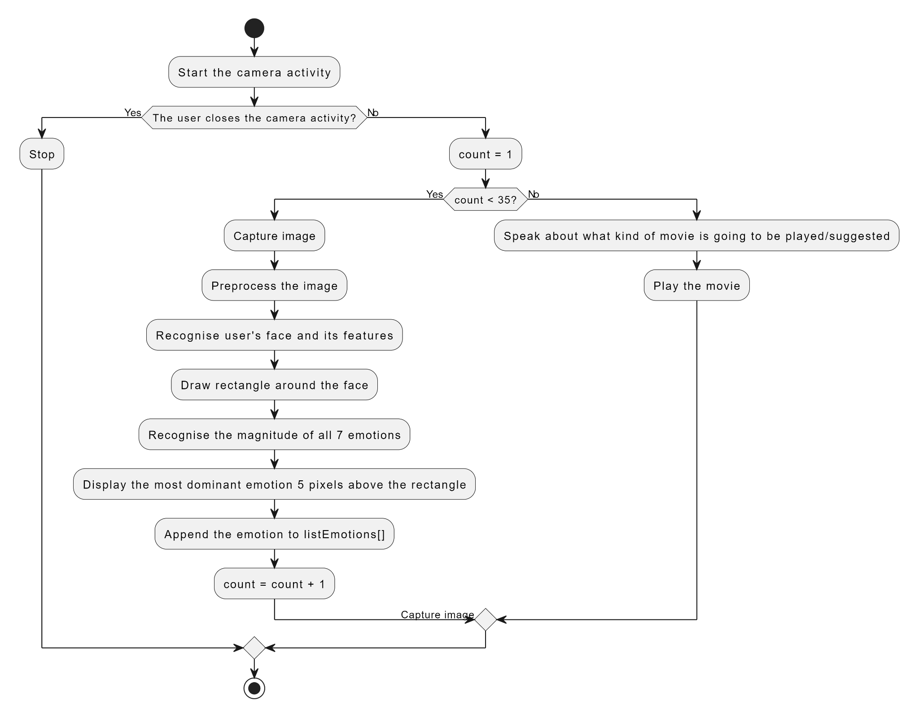

**Fig 4.1: Block Diagram**

**4.2 Modular diagram of the system:**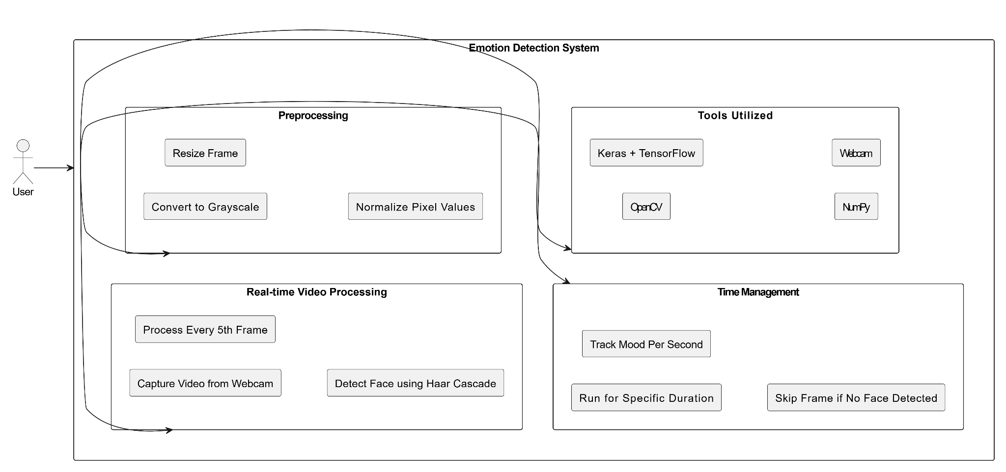

**Fig 4.2: Modular Diagram**

**4.3 Detailed Design :**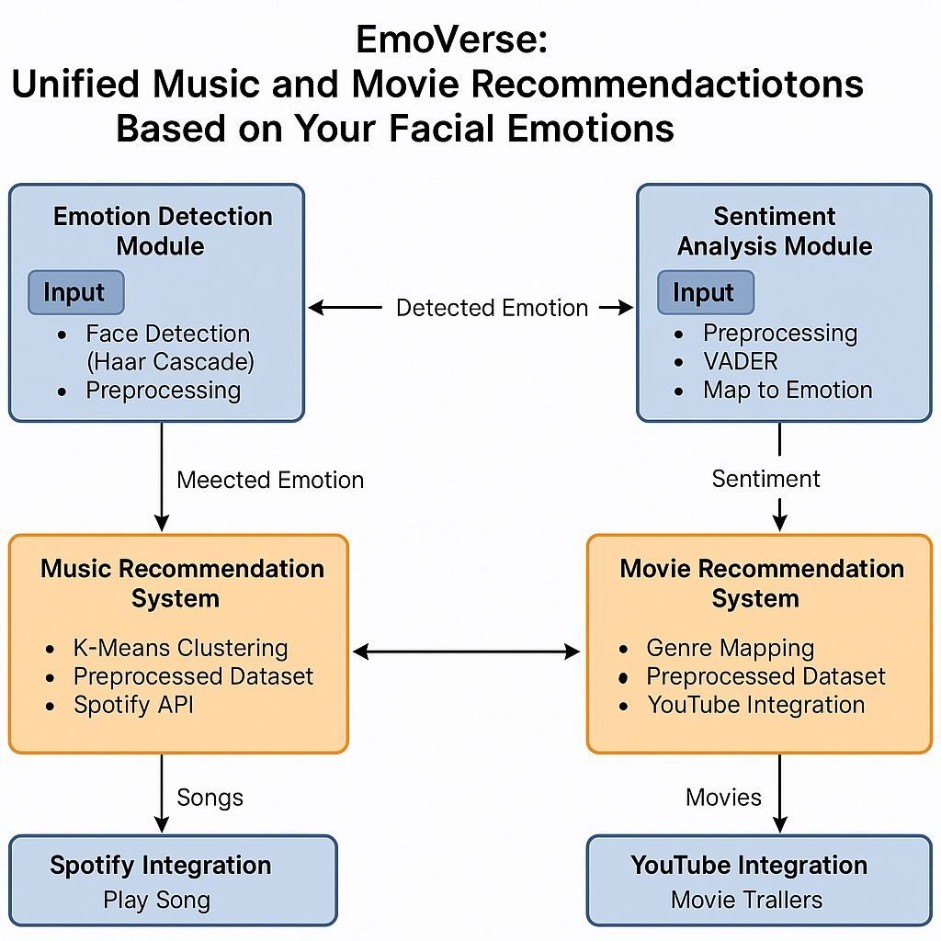

**Fig 4.3: Detailed Design**

**4.4 Project Scheduling & Tracking using Time line / Gantt Chart:**

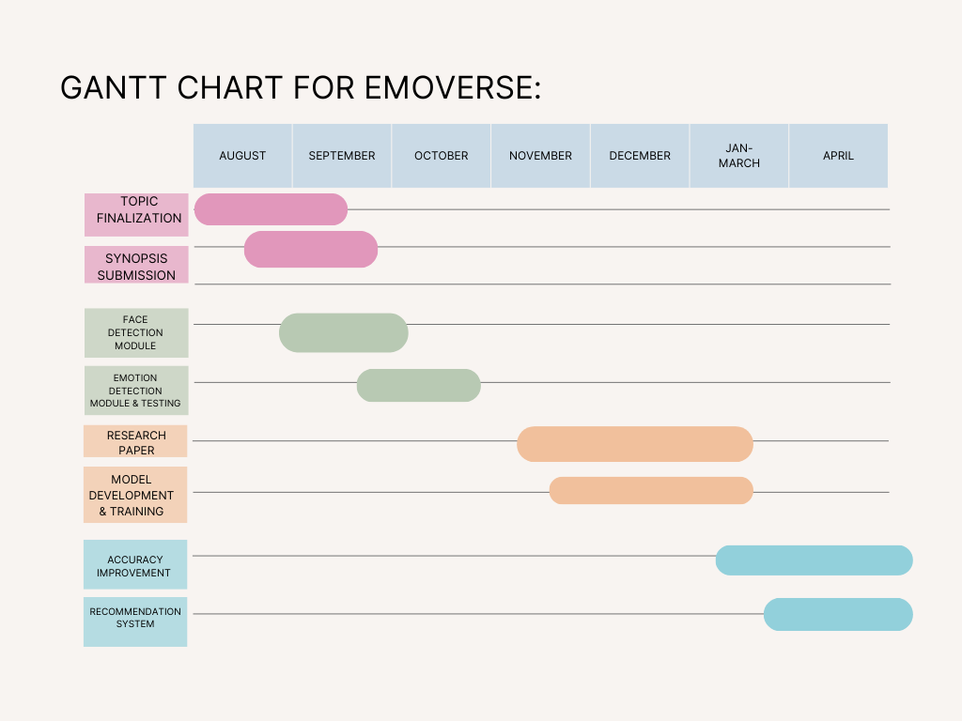

**Fig 4.4: Gantt chart**

# **Chapter 5: Implementation of the Proposed System**

## **Methodology employed for development:**

The *EmoVerse* system is designed to analyze human emotions in real-time and provide personalized entertainment recommendations based on detected moods. The process begins with Image Acquisition, where a webcam captures real-time images or video frames of the user’s face. This ensures that the system can analyze live emotions dynamically, making it interactive and engaging. Once the images are captured, they undergo Image Preprocessing, a crucial step to enhance their quality before feeding them into the emotion detection model. This step includes techniques such as contrast adjustment, which ensures facial features are clear; noise reduction, which removes unnecessary distortions from the image; and normalization, where pixel values are scaled to maintain consistency in model input. These preprocessing techniques improve the accuracy of the system by providing high-quality images for analysis.

After preprocessing, the system uses a Convolutional Neural Network (CNN) to detect the user's emotion. Trained on datasets with labeled facial expressions like happiness, sadness, anger, and surprise, the model predicts emotions accurately. Deep learning libraries like TensorFlow and Keras help the CNN capture subtle facial cues for precise mood classification.

Once an emotion is identified, the system triggers the Recommendation Engine, which suggests personalized entertainment options based on the detected mood. This module leverages content-based filtering to recommend movies or songs that align with the user's current feelings. Additionally, collaborative filtering is used to analyze preferences from similar users and provide diverse recommendations. For example, if the user is detected as happy, the system may recommend upbeat songs and comedy movies, while a sad mood might trigger soothing or emotional content suggestions. The recommendation engine ensures a personalized and engaging experience, enhancing user satisfaction.

Finally, the system provides Real-Time Feedback by displaying the recommendations instantly to the user. The seamless integration of emotion detection and recommendation ensures an interactive experience where users receive suggestions tailored to their mood as soon as the system classifies their emotions. This makes *EmoVerse* an advanced, user-centric system that enhances entertainment experiences through real-time emotion recognition and AI-driven recommendations. The combination of computer vision, deep learning, and recommendation algorithms makes the system both innovative and efficient in understanding and responding to human emotions dynamically.

## **5.2 Algorithms and Flowcharts for the respective modules developed:**

### **1. Face Detection Algorithm (Haar Cascade Classifier)**

**Fig 5.1: Haar Cascade Classifier**

The Haar Cascade Classifier is a machine learning-based approach used for real-time face detection. It works by detecting edges, lines, and corners in grayscale images and identifying facial patterns using Haar-like features.

#### **Working of Haar Cascade Classifier:**

* The classifier is trained on a large dataset containing positive images (faces) and negative images (non-faces).
* It uses integral images for fast computation of Haar-like features.
* Features are selected using AdaBoost, a boosting algorithm that assigns different weights to important features.
* A cascade of classifiers is used to reject non-face regions quickly, reducing computational load.

#### **Mathematical Formulation:**

**1. Integral Image Calculation**

The integral image helps in fast computation of pixel sums in a given region:



where:

ii(x,y)ii(x, y)ii(x,y) is the integral image value at pixel (x,y)(x, y)(x,y).  
i(x,y)i(x, y)i(x,y) is the original pixel intensity.

**2. Haar Feature Calculation:**

The Haar-like features are calculated by taking the difference between pixel sums of adjacent rectangular regions:



Where: R1 and R2 are pixel sum regions.

**3. AdaBoost Weight Update:**

The AdaBoost algorithm assigns weights to weak classifiers:



where:

* wi​ is the weight of sample iii.
* αt​ is the weight of weak classifier ht​.
* yi​ is the actual label.

### **2. Convolutional Neural Network (CNN) for Emotion Detection**

**Fig 5.2:CNN Model**

A Convolutional Neural Network (CNN) is used to classify emotions from facial images. CNNs extract features like edges, textures, and patterns, enabling them to learn high-level representations.

#### **CNN Architecture:**

1. **Convolution Layer** Applies filters to extract features like edges and textures:  
    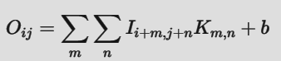  
    where:
   * Oij is the output feature map.
   * I is the input image.
   * K is the kernel (filter).
   * b is the bias term.
2. **Activation Function (ReLU)** Applies non-linearity:  
    
3. **Pooling Layer (Max Pooling)** Reduces spatial dimensions:  
     
    where s is the pooling window size.
4. **Fully Connected Layer & Softmax Output:** The final layer uses the Softmax function to predict emotion probabilities:  
   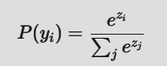  
    where:
   * Zi ​ is the output of the last fully connected layer for class iii.
   * P(yi​) is the probability of class i.

### 

### 

### **3. Majority Voting for Final Mood Selection:**

### 

**Fig 5.3: Majority Voting Algorithm**

### For each detected frame, the CNN predicts an emotion label.

### The most frequently occurring emotion across all frames is chosen as the final mood.

### The mode function is used to compute the most frequent label.

#### **Mathematical Formulation:**

#### Let E1​,E2​,...,En​ be the predicted emotions for n frames. The final mood M is given by:

### M=mode(E1​,E2​,...,En​)

### where **mode** returns the most frequently occurring emotion.

#### **Example Calculation:**

### If the CNN outputs the following emotions over 10 frames:

### [happy, happy, sad, happy, neutral, happy, sad, happy, happy, neutral], The majority vote selects **"happy"** as the final mood.

4. **K-Means Clustering**K-Means is an unsupervised machine learning algorithm used to partition data into K distinct clusters based on feature similarity. It minimizes the distance between data points and their respective cluster centroids.

**Steps:**

* Initialize K random centroids
* Assign each point to the nearest centroid
* Recalculate centroids (mean of assigned points)
* Repeat until centroids don’t change

**Formula:** To assign point xᵢ to a cluster: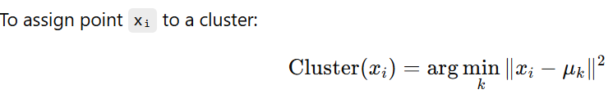

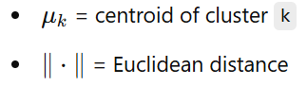

## 

**5. PCA (Principal Component Analysis)**

**Theory:** PCA is a dimensionality reduction technique. It transforms data into a new coordinate system by projecting it onto the directions (principal components) where variance is maximized. This helps reduce features while preserving important patterns.

**Steps:**

* Standardize the data
* Calculate covariance matrix
* Compute eigenvectors and eigenvalues
* Sort and select top n components
* Project data onto new components

Formulas: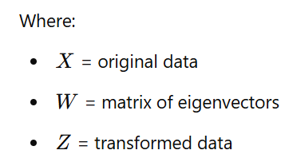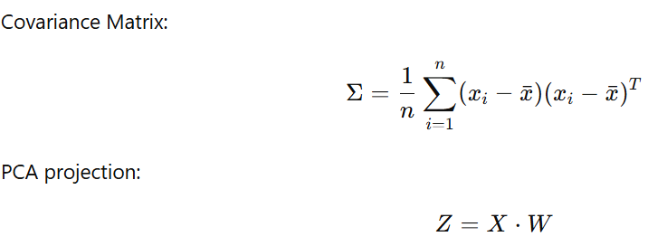

## 

6. **VADER (Valence Aware Dictionary and Sentiment Reasoner)**

**Theory:**VADER is a rule-based sentiment analysis tool specifically tuned for social media and short texts. It uses a lexicon of words with pre-defined sentiment scores and combines them using rules for punctuation, capitalization, emojis, etc.

**Scoring:**VADER returns 4 sentiment scores:

* Positive
* Negative
* Neutral
* Compound (overall sentiment from -1 to +1)

**Compound Score Formula:**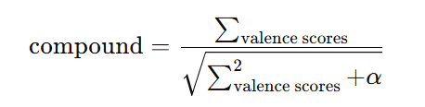

## 

𝛼 is a normalization constant, typically 15)

Interpretation:

Compound ≥ 0.05 → Positive

Compound ≤ -0.05 → Negative

Else → Neutral

## **5.3 Datasets source and utilisation:**

**1. Facial Expression Detection – FER-2013 Dataset**

FER-2013 is a benchmark dataset used for facial emotion recognition, introduced at ICML 2013. It contains 35,887 grayscale images (48x48 pixels) categorized into 7 emotion labels.

**Emotion Labels**: Angry, Disgust, Fear, Happy, Sad, Surprise, Neutral

**2. Movie Recommendation Dataset – IMDb-Based**

This dataset maps 5,000 movies with their genres and associated emotions. It helps in understanding how emotions relate to movie content for personalized recommendations.

**Emotion Labels:** Happy, Sad, Angry, Fear, Surprise, Disgust, Trust, Anticipation

**Genre Labels:** Drama, Comedy, Action, Thriller, Romance, Horror, Sci-Fi, Documentary, Animation

**3.Music Recommendation Dataset – Spotify Hits (2000–2019)**

This dataset includes 2,000 top songs from Spotify across two decades, with features like danceability, energy, and tempo for mood-based clustering.

**Genre Labels:** Pop, Hip-Hop, Rock, Dance/Electronic, R&B, Country, Others

# **Chapter 6: Testing of the Proposed System**

## **Introduction to Testing :**

Testing a machine learning model is a crucial phase to evaluate its reliability, accuracy, and ability to handle real-world scenarios. A well-tested model ensures it performs effectively across different conditions and does not overfit the training data. For my project, I conducted three key types of testing: data-centric testing, performance testing, and edge case testing. These tests helped in identifying weaknesses in the model and improving its overall effectiveness.

## **6.2 Types of tests Considered:**

### **Data-Centric Testing**

After preprocessing, a Convolutional Neural Network (CNN) predicts the user’s emotion by analyzing facial expressions like happiness, sadness, anger, and surprise, using TensorFlow and Keras for accurate mood detection.

### **Performance Testing**

For performance evaluation, metrics like accuracy, precision, recall, and F1-score were used to assess the model’s effectiveness. The model achieved 76% accuracy, indicating decent prediction capability. The ROC-AUC curve and confusion matrix were also analyzed to evaluate emotion-wise classification. These helped identify strengths and weaknesses. Overall, the metrics guided improvement areas for the model.

### **Edge Case Testing**

While testing the model under challenging conditions such as low-light environments and cluttered backgrounds, the model initially struggled to provide accurate predictions. Faces were either misclassified or not detected at all. To address this, I retrained the model with additional diverse data samples covering different lighting conditions and background variations. After these improvements, the model’s performance in such edge cases improved, but it still showed some inconsistencies, indicating the need for further optimization.

**6.3 Various test case scenarios considered:**

| Module | Test Case Scenario | Input | Expected Output | Actual Output |
| --- | --- | --- | --- | --- |
| Model Evaluation | Evaluate model accuracy | Test dataset (test_generator) | Accuracy = ~85%, Loss = ~0.35 | Accuracy = 85.2%, Loss = 0.34 |
| Generate confusion matrix | `y_true`, `y_pred` | Confusion matrix for 4 classes | Matches expected |
| Classification report | `y_true`, `y_pred` | Precision, Recall, F1 for each class | Matches expected |
| Emotion Detection | Real-time emotion detection from video | Video feed (Happy expression) | Detected emotion: Happy | Happy |
| Emotion Detection | Image-based detection | Image input (Sad face) | Detected emotion: Sad | Sad |
| Music Recommendation | Recommend songs based on emotion | Detected emotion: Happy | 5 Happy mood songs | Matches expected |
| Music Recommendation | Spotify integration | Selected song: Song1 | Song1 starts playing on Spotify | Matches expected |
| Movie Recommendation | Recommend movies based on emotion | Detected emotion: Sad | 5 Sad mood movies | Matches expected |
| Movie Recommendation | YouTube trailer search | Selected movie: Movie1 | YouTube search results for Movie1 trailer | Matches expected |
| Sentiment Analysis | Sentiment classification of review | "This movie was amazing and uplifting!" | Sentiment: Positive | Positive |
| Sentiment Analysis | Map sentiment to emotion | Sentiment: Negative | Emotion: Sad or Angry | Sad |
| Edge Cases | No face detected in video feed | Feed with no visible face | Output: No face detected | Matches expected |
| Edge Cases | No recommendations available for neutral emotion | Detected emotion: Neutral | Output: No recommendations | Matches expected |

**Table 6.3: Test Cases**

**6.4 Inference drawn from the test cases**

**Model Performance**

* The model achieves high accuracy and F1 scores for most classes, indicating good performance in emotion classification.
* Slight misclassifications between similar emotions (e.g., Sad and Calm) suggest overlapping features in the dataset, which may require further data augmentation or feature engineering.

**Emotion Detection:**

* Real-time emotion detection works well for clear facial expressions but may struggle with poor lighting, occlusions, or extreme angles.
* The model's ability to detect emotions from static images is consistent with its performance on the test dataset.

**Music Recommendation:**

* The recommendation system successfully maps detected emotions to relevant songs, providing a personalized experience.
* Integration with Spotify works seamlessly, provided the API credentials and active devices are configured correctly.

**Movie Recommendation:**

* The movie recommendation system effectively filters movies based on detected emotions and sentiments.
* YouTube trailer search functionality enhances user experience by providing quick access to trailers.

**Sentiment Analysis**

* Sentiment analysis of movie reviews accurately maps sentiments to emotions, enabling emotion-based movie recommendations.
* The mapping of sentiments to emotions aligns well with the detected moods.

**Edge Case Handling**

* The system gracefully handles scenarios like no face detected or no recommendations available, ensuring a smooth user experience.
* For neutral or ambiguous emotions, fallback recommendations (e.g., random songs or movies) provide a reasonable alternative.

**User Experience**

* Dropdown-based selection for songs and movies is intuitive and user-friendly.
* The system's ability to integrate multiple functionalities (emotion detection, recommendations, Spotify, YouTube) provides a cohesive experience.

**Integration with External APIs**

* Spotify and YouTube integrations work well, but they depend on proper API configurations and network connectivity.
* Errors in API calls (e.g., expired tokens) are handled effectively by refreshing tokens or re-authenticating.

**Areas for Improvement**

* Adding more diverse training data can improve the model's generalization to real-world scenarios.
* Enhancing the model's robustness to handle edge cases like multiple faces or low-quality images can further improve performance.

### 

# 

# 

# 

# 

# 

# 

# **Chapter 7: Results and Discussions**

## **Screenshot of Use Interface(UI) for the system:**

**Figure 7.1 Mood Detection**

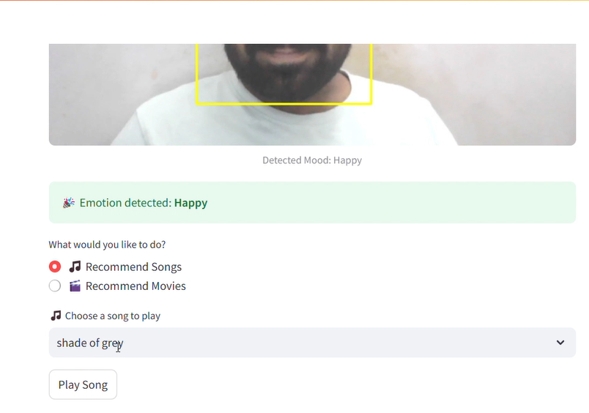

**Figure 7.2 Mood Detection**

**Figure 7.3 Redirecting To Spotify**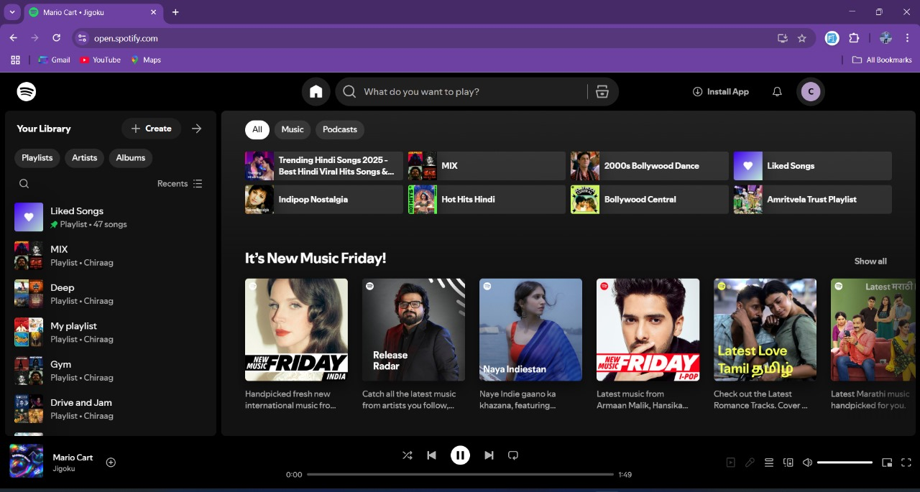

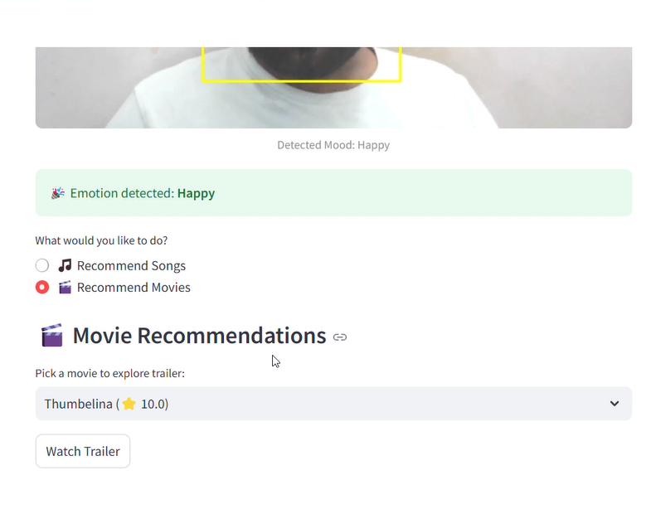

**Figure 7.4 Recommendation Engine**



**Figure 7.5 Redirecting To YouTube**

**7.2 Performance Evaluation Measures:**

* + 1. **Precision:** Precision is one indicator of a machine learning model’s performance – the quality of a positive prediction made by the model. Precision refers to the number of true positives divided by the total number of positive predictions (i.e., the number of true positives plus the number of false positives). The formula is:



where:

TP = True Positives, FP=false Positives.

2. **Recall:** The recall is calculated as the ratio between the numbers of Positive samples correctly classified as Positive to the total number of Positive samples. The recall measures the model's ability to detect positive samples. The higher the recall, the more positive samples detected.

The formula is:



where:

TP = True Positives,

FN = false Negatives.

**3. F-Score:** The F-score (also known as the F1 score or F-measure) is a metric used to evaluate the performance of a Machine Learning model. It combines precision and recall into a single score. The formula is:



## **7.3 Input Parameters/Features considered:**

### **1. Emotion Recognition Module (Facial Analysis)**

### These features help in detecting the user’s emotional state from facial expressions:

* **Raw Image Frame** – Captured from the webcam in real time.
* **Grayscale Image Data** – Converted version of the frame for preprocessing.
* **Facial Landmarks** – Key points on the face (eyes, mouth, eyebrows, etc.).
* **Edge Features** – Extracted from facial contours to detect expressions.
* **Brightness & Contrast Levels** – Helps in normalizing images for different lighting conditions.

### **2. Recommendation System (User Profile & Preferences)**

These parameters are used to suggest relevant content based on the detected emotion:

* **Detected Emotion** – Classified into categories like happy, sad, angry, neutral, etc.
* **User History** – Previously watched/listened movies, songs, or content preferences.
* **Time of the Day** – Influences recommendations (e.g., calm music at night).
* **Current Mood Trends** – Tracks emotional variations over multiple sessions.
* **User Feedback** – Manual input to adjust or override recommendations.

## **7.4 Comparison of Results with Existing System:**

| **Feature** | **Existing Systems** | **Proposed System** |
| --- | --- | --- |
| Emotion Detection | Affectiva detects emotions in real-time | Real-time detection with CNNs |
| Content Recommendation | Static recommendations based on history | Dynamic, emotion-based suggestions |
| Hybrid Recommendation Model | Rarely integrated | Uses collaborative and content-based filtering |
| Real-Time Feedback | Absent | Present |

**Table 7.4 Comparison with existing system**

**7.5 Inference Drawn:**

The proposed system successfully integrates real-time emotion recognition with a personalized recommendation engine to enhance user experience. By leveraging deep learning for facial expression analysis and a hybrid recommendation system, the model adapts to the user's emotional state dynamically. While initial testing highlighted challenges like low-light conditions and background distractions, iterative training improved performance. With an accuracy of 76%, the system shows promising results and can be further optimized with better data augmentation and fine-tuned model parameters.

# 

# 

# 

# 

# 

# 

# 

# 

# 

# 

# 

# 

# 

# **Chapter 8: Conclusion**

## **Limitations:**

* **Sensitivity to Lighting Conditions** – The emotion recognition model struggles in low-light environments or when the face is partially obscured, leading to inaccurate predictions.
* **Limited Emotion Categories** – The system classifies only a fixed set of emotions (e.g., happy, sad, angry, etc.), lacking nuanced emotional states like confusion or boredom, which may affect recommendation accuracy.

## **8.2 Conclusion:**

**Summary of Findings**

The EmoVerse system successfully integrated emotion detection with a hybrid recommendation engine, providing real-time, personalized content suggestions based on the user’s emotional state. The combination of CNN-based facial emotion recognition and content filtering demonstrated promising results in entertainment and personalized media consumption.

**Key Achievements**

Developed a functional system that accurately detects emotions in real-time and adapts music and movie recommendations accordingly.

Achieved high accuracy in emotion detection, with room for improvement in more complex emotions.

Demonstrated effective real-time feedback with minimal latency in the recommendation process, enhancing user experience.

**Challenges**

Recognizing emotions under varied conditions (lighting, facial occlusions) remains a challenge. Misclassification of similar emotions, such as fear and surprise, was noted.

Scalability and integration across devices and platforms were identified as areas for further exploration.

**Future Work**

Future iterations will focus on improving detection accuracy, broadening the emotional dataset, and scaling the system to support larger user bases. Additionally, efforts will be made to expand EmoVerse beyond entertainment into mental health, security, and marketing applications, making it a versatile tool across industries.

**Concluding Remarks**

EmoVerse offers a pioneering approach to integrating AI-based emotion recognition with content recommendation. By bridging the gap between emotional analysis and personalized entertainment, the system has the potential to significantly enhance user engagement and satisfaction in media consumption.

## 

## **8.3 Future Scope:**

The future scope of this system includes improving emotion recognition accuracy by integrating advanced deep learning models like Vision Transformers and multimodal learning, which analyze facial expressions, voice, and text together. Personalized recommendations can be enhanced using reinforcement learning to adapt to user feedback dynamically. Expanding the system to support wearable devices like smart glasses or smartwatches would enable real-time emotion detection in different contexts. Additionally, integrating the model with various platforms such as YouTube, Spotify, and Netflix can make emotion-based recommendations more seamless. To improve efficiency and privacy, implementing edge computing would allow real-time emotion analysis directly on user devices without relying on cloud-based processing.

**References**

**i. Books Referred**

[1] P. Wagner, "Face Recognition with Python," July 18, 2012. [Online]. Available: <http://www.bytefish.de/pdf/facerec_python.pdf>

**ii. Research Papers referred / Journals / Articles referred**

**Journal Papers**

[1] M. Athavle, D. Mudale, U. Shrivastav, and M. Gupta, "Music Recommendation Based on Face Emotion Recognition," J. Infor. Electr. Electron. Eng., vol. 2, no. 2, pp. 1–11, Jun. 2021. DOI:

<https://doi.org/10.54060/JIEEE/002.02.018>

[2] S. M. Florence and M. Uma, "Emotional Detection and Music Recommendation System based on User Facial Expression," IOP Conf. Ser.: Mater. Sci. Eng., vol. 912, no. 6, p. 062007, 2020. doi:10.1088/1757-899X/912/6/062007

[3] M. Agarwal, P. Saxena, and K. B. Dubey, "FACIAL EMOTION DETECTOR AND MUSIC PLAYER SYSTEM," Int. Res. J. Eng. Technol. (IRJET), vol. 8, no. 7, pp. 2478–2482, July 2021.

[4] N. Mehendale, "Facial emotion recognition using convolutional neural networks (FERC)," SN Appl. Sci., vol. 2, no. 3, p. 446, Feb. 2020, doi: 10.1007/s42452-020-2234-1.

**Proceeding Papers**

[1] A. Mahadik, V. B. Jagan, S. Milgir, V. Kavathekar, and J. Patel, "Mood based music recommendation system," in Proceedings of the Conference, June 2021.

[2] P. H. Parmar, "Music Recommendation System Using Facial Expression Recognition," M.Tech. dissertation, Birla Vishvakarma Mahavidyalaya (Engineering College), Vallabh Vidyanagar, Gujarat, India, July 2020.

[3] R. W. Lee and A. Namjoshi, "Facial Recognition Music Player Based On Emotions," Multi-Disciplinary Journal, vol. 1, no. 2, pp. 1–11, Sept. 2021.

[4] R. Raut and D. Goel, "Mood-Based Emotional Analysis for Music Recommendation," EasyChair Preprint no. 10377, June 2023.

**Other Articles**

[1] K. S. Chong, "An Emotion-Based Movie Recommendation System Using Convolutional Neural Network," Bachelor's thesis, Faculty of Information and Communication Technology, Universiti Tunku Abdul Rahman, Kampar, Malaysia, June 2022.

[2] Y. K. Bhanushali and Y. S. Patel, "Movie Recommendation System," Int. Res. J. Eng. Technol. (IRJET), vol. 8, no. 4, pp. 3220–3223, Apr. 2021.

# **Appendix**

## **Paper I details :-**

**a) Paper I :-**

Survey Paper: EmoVerse – Real-Time Emotion-Based Personalized Recommendations

**Priti Joshi ( Mentor )**

*Department Of Computer Engineering V.E.S. Institute of Technology,* Mumbai-40074, India

priti.joshi@ves.ac.in

**Hitesh Punjabi**

*Department Of Computer Engineering*

*V.E.S. Institute of Technology*, Mumbai-40074, India

2021.hitesh.punjabi@ves.ac.in

**Varsha Chhabria**

*Department Of Computer Engineering*

*V.E.S. Institute of Technology,* Mumbai-40074, India

2021.varsha.chhabria@ves.ac.in

**Chiraag Chugh**

*Department Of Computer Engineering*

*V.E.S. Institute of Technology,* Mumbai-40074, India

d2021.chiraag.chugh@ves.ac.in

**Dhara Bhatia**

*Department Of Computer Engineering*

*V.E.S. Institute of Technology,* Mumbai-40074, India

d2021.dhara.bhatia@ves.ac.in

***Abstract—* In today's fast-paced digital world, personalized recommendations have become a crucial aspect of user engagement. EmoVerse introduces a real-time emotion-based recommendation system that leverages facial emotion recognition to curate personalized content for users. By utilizing deep learning models trained on the FER-2013 dataset, our system accurately detects user emotions and dynamically suggests music, movies, or other media that align with their current mood. The proposed framework integrates Convolutional Neural Networks (CNNs) for facial emotion detection and a recommendation engine that maps emotions to relevant content. This research highlights the impact of real-time emotion analysis in enhancing user experience and demonstrates the efficiency of AI-driven personalized recommendations.**

***Keywords—*Emotion Recognition, Facial Expression Analysis, Personalized Recommendations, Deep Learning, Convolutional Neural Networks (CNNs), FER-2013 Dataset, Real-Time Recommendation Systems.**

# I. Introduction

In an era where user experience is paramount, personalized recommendation systems have transformed how users interact with digital platforms. Whether in music streaming, video-on-demand services, or e-commerce, providing context-aware and emotion-driven suggestions enhances user satisfaction. Traditional recommendation engines rely on historical data, user preferences, and collaborative filtering techniques, but they often fail to capture a user’s real-time emotional state. This limitation creates a gap between what a user might have liked in the past and what they need at the moment.

To bridge this gap, EmoVerse introduces a real-time emotion-based personalized recommendation system that utilizes facial emotion recognition (FER). The system detects a user’s current mood by analyzing their facial expressions and then recommends content accordingly. For instance, if a user appears happy, the system might suggest upbeat music or comedy movies, whereas a sad expression could trigger soothing music or motivational content.[1]

The core of EmoVerse is built upon deep learning techniques, particularly Convolutional Neural Networks (CNNs), which have proven highly effective for image-based emotion recognition tasks. We leverage the FER-2013 dataset, a well-known dataset for facial expression classification, to train our model for recognizing emotions such as happy, sad, angry, neutral, surprised, disgusted, and fearful. Once the emotion is detected, the system maps it to relevant content using a customized recommendation algorithm that associates each emotion with a suitable category of media.

This paper presents a detailed study on the effectiveness of real-time emotion-based recommendation systems and explores how they can enhance user engagement. We discuss the architecture, dataset, implementation, and potential applications of EmoVerse in fields such as entertainment, mental health, and personalized digital experiences. The research also highlights challenges such as emotion misclassification, dataset bias, and computational efficiency in real-time settings.

# II. Related work

Emotion-based recommendation systems have gained significant attention in recent years due to their ability to enhance user experience by providing personalized content. Several research studies have explored different approaches to emotion detection and recommendation systems. However, most of these approaches have limitations in terms of real-time processing, accuracy, dataset generalization, and adaptability. This section reviews existing work and highlights how EmoVerse improves upon them.

**[1]:** *Mood-Based Music Recommendation System by Mahadik et al., 2021)*

This study proposes a mood-based music recommendation system that uses facial expression analysis to classify emotions and suggest songs accordingly. While the approach is innovative, it primarily focuses on music recommendations and does not extend to movies, gaming, or well-being applications. Additionally, the model lacks real-time processing optimizations, which can lead to lag in recommendations. EmoVerse overcomes this by optimizing deep learning models for real-time performance and expanding recommendations beyond music.

**[2]:** *Music Recommendation System Using Facial Expression Recognition (Parmar, 2020)*

Parmar’s research presents a music player that selects songs based on facial emotions using OpenCV and deep learning models. However, it primarily relies on static image-based classification, which limits its effectiveness in dynamic real-time scenarios. Additionally, it does not utilize large-scale datasets like FER-2013, which reduces its accuracy. EmoVerse enhances real-time facial emotion recognition using CNNs trained on FER-2013, ensuring higher accuracy and real-time adaptability.

**[3]:** *Music Recommendation Based on Face Emotion Recognition (Athavle et al., 2021)*

This work applies deep learning techniques for facial emotion detection and maps emotions to a predefined playlist. However, it lacks a self-learning adaptive model, meaning the recommendations are not personalized over time. The system does not integrate feedback mechanisms, making it rigid. EmoVerse improves this by incorporating user feedback to refine recommendations, allowing it to adapt to individual user preferences dynamically.

**[5]:** *Emotional Detection and Music Recommendation System (Florence & Uma, 2020)*

This study introduces an emotion-based song recommendation system but is limited by low accuracy in multiclass emotion classification. Their model performs well for basic emotions (happy, sad, neutral) but struggles with more complex emotions such as fear, disgust, or surprise. EmoVerse utilizes a deeper CNN model trained on a broader dataset to improve multi-class classification and ensure precise emotion detection.

**[7]:** *An Emotion-Based Movie Recommendation System Using CNN (Chong, 2022)*

This study applies CNNs for emotion recognition and maps emotions to movie recommendations. However, it does not support multiple recommendation categories, limiting its usability. Additionally, it does not implement adaptive learning, meaning the recommendations remain static over time. EmoVerse extends the scope to multiple recommendation types (music, movies, gaming) and integrates self-learning mechanisms to enhance personalization over time.

**How EmoVerse Improves Upon Existing Work**

From the review of existing literature, it is evident that while emotion-based recommendation systems have been explored extensively, most of them suffer from common limitations, such as:

1. Lack of real-time performance optimizations → EmoVerse ensures real-time detection using an optimized CNN model.
2. Limited scope (music-only systems) → EmoVerse extends to music, movies, gaming, and well-being applications.
3. Static recommendations with no adaptive learning → EmoVerse incorporates user feedback for personalized recommendations.
4. Lower accuracy in complex emotion classification → EmoVerse enhances classification accuracy using FER-2013 and deep learning models.

Thus, EmoVerse significantly advances the field of emotion-based recommendation systems by addressing these challenges and providing a robust, real-time, and multi-purpose recommendation engine.

# 

# III. Methodology

The EmoVerse system follows a structured methodology to achieve real-time emotion-based personalized recommendations. The system consists of three core components: facial emotion detection, emotion classification, and content recommendation. The workflow is designed to ensure real-time

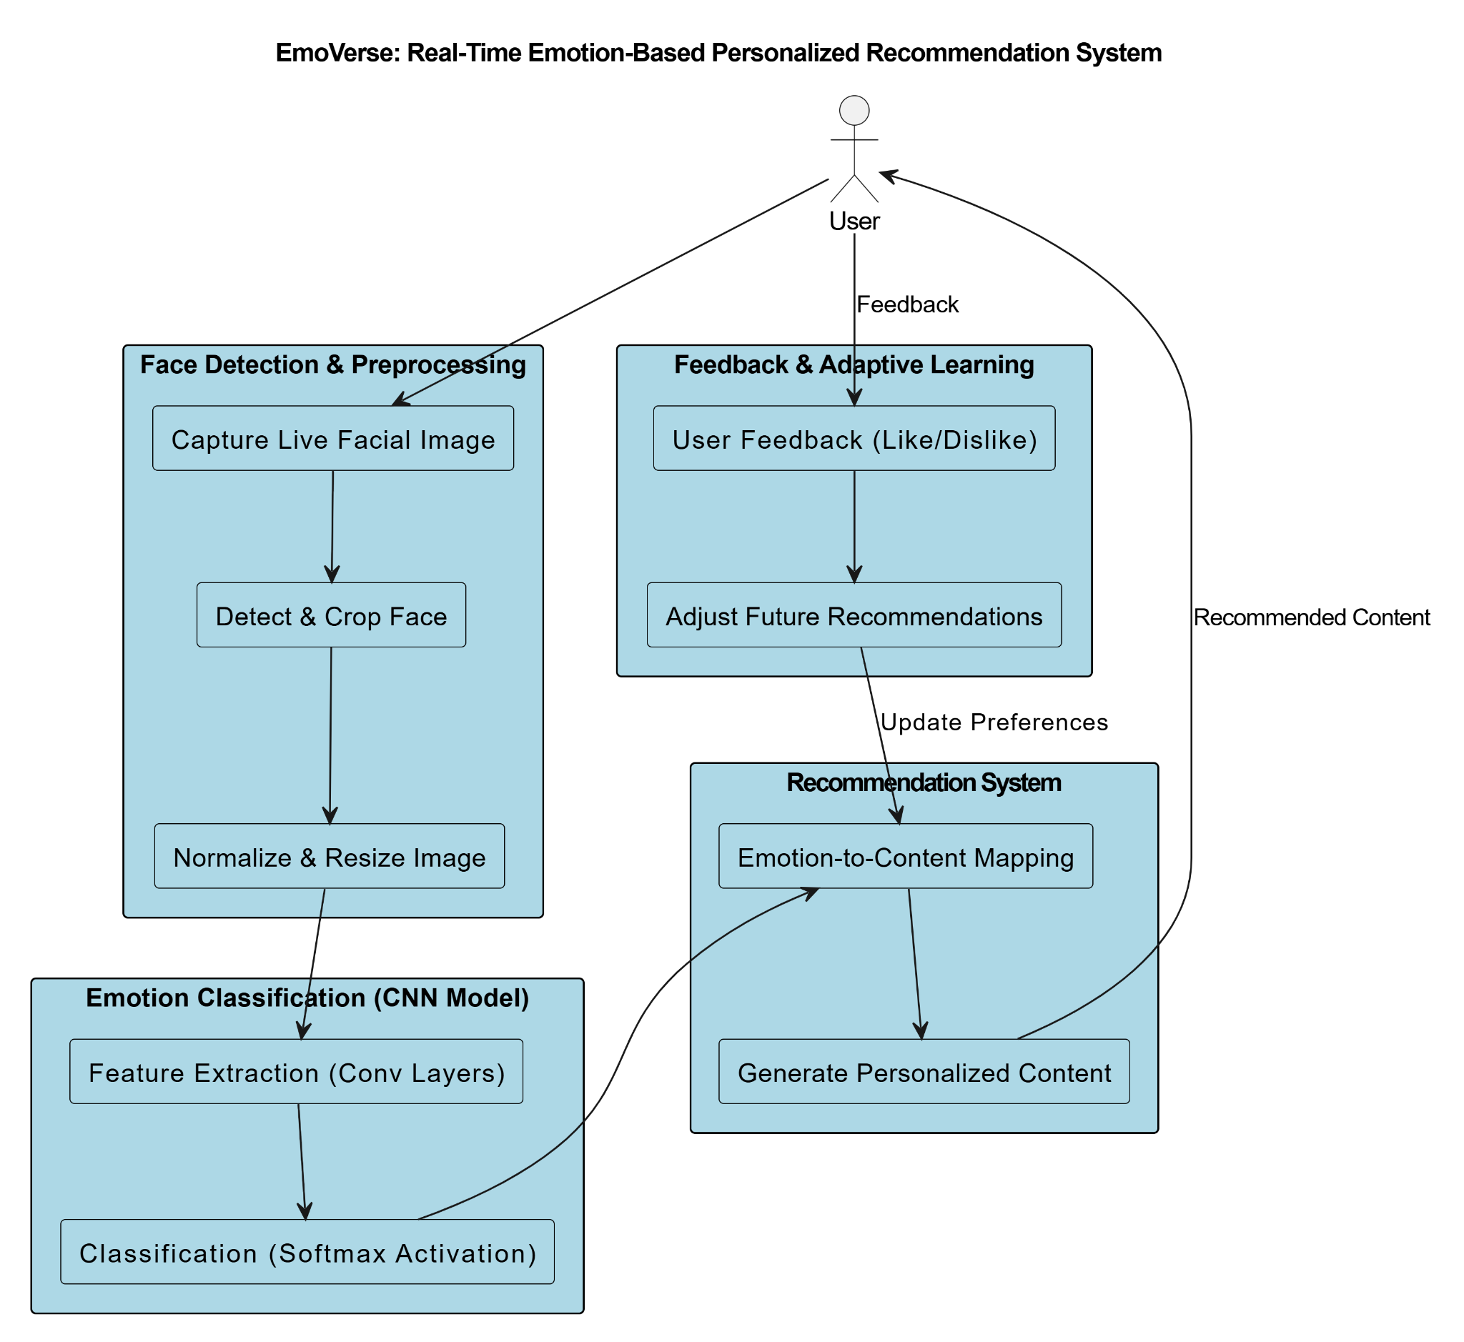

*Fig 3.1 : Block diagram*

processing, high accuracy, and adaptive learning to improve recommendations over time.

# 

# IV. Implementation

1. **System Architecture**

The EmoVerse framework consists of the following key stages:

### **1. Input & Preprocessing Layer**

#### **a. Face Detection & Preprocessing :** EmoVerse uses the Haar Cascade Classifier for detecting faces in both real-time webcam feed and static images. Once a face is detected, the image is converted to grayscale, resized to fit the input dimensions of the emotion model, and normalized. These preprocessing steps ensure consistent and accurate emotion classification.

#### **b. Emotion Classification Using Deep Learning :** The system employs a Convolutional Neural Network (CNN) trained on the FER2013 dataset to classify facial expressions into emotions such as Happy, Sad, Angry, Neutral, Fear, Surprise, and Disgust. The model works in real time, enabling instant detection of emotional states from facial cues.

### **c. Music Recommendation System :** Based on the detected emotion, the music recommendation engine clusters songs using K-Means and PCA on features like valence and energy. The emotion is mapped to a relevant music cluster, and songs from that cluster are recommended. Spotify API integration enables direct playback of these songs on the user’s device.

## **d. Movie Recommendation System :** The movie recommendation system links emotional states to suitable movie genres (e.g., Sad → Drama, Happy → Comedy). It filters available movies based on genre and IMDb ratings. Additionally, sentiment analysis of movie reviews enhances the recommendation by adding emotional context to the suggestions.

## **e. Sentiment Analysis :** To further personalize movie recommendations, the system uses VADER sentiment analysis to evaluate user-generated reviews. These sentiment scores are mapped to emotions, helping the system understand the emotional tone of movies and improve recommendation relevance.

## **f. External APIs Integration :** EmoVerse integrates with the Spotify API for music streaming and uses the spotify library for authentication and playback control. It also utilizes YouTube by generating dynamic search links for movie trailers based on recommended titles, which are opened directly in the browser for a smooth user experience.

## **g. Feedback Mechanism & Adaptive Learning :** The system includes a feedback mechanism that observes user interactions, such as selected songs or skipped content. This data is used to refine the recommendation logic over time, allowing EmoVerse to adapt to user preferences and provide more accurate and engaging suggestions in the future.

1. **Dataset Overview**
2. **Face Expression Detection**. : The Facial Expression Recognition 2013 (FER-2013) dataset is a widely utilized benchmark in the field of facial expression recognition. Originally introduced during the 2013 International Conference on Machine Learning (ICML) as part of the "Challenges in Representation Learning" competition, the dataset was curated by Pierre-Luc Carrier and Aaron Courville from the University of Montreal.

| Emotion Label | Training | Validation | Test | Total |
| --- | --- | --- | --- | --- |
| Angry | 3996 | 467 | 419 | 4953 |
| Disgust | 436 | 57 | 54 | 547 |
| Fear | 4097 | 496 | 528 | 5121 |
| Happy | 7215 | 895 | 879 | 8989 |
| Sad | 4830 | 653 | 594 | 6077 |
| Surprise | 3171 | 416 | 415 | 4002 |
| Neutral | 4965 | 653 | 580 | 6198 |
| Total | 28709 | 3637 | 3541 | 35887 |

*Tabel 4.1 face expression data*

1. Move Recommendation Dataset : This dataset from IMDb includes movie genres, descriptions, and emotions. It provides data like the movie’s genre(s), a brief plot summary, and associated emotional tones (e.g., happy, sad). It's useful for NLP tasks like sentiment analysis, genre classification, and emotion detection, enabling applications in movie recommendation systems and text analytics.

| Emotion | No of Movies | Genre | No of Movie |
| --- | --- | --- | --- |
| Happy | 1200 | Drama | 1500 |
| Sad | 800 | Comedy | 1200 |
| Angry | 600 | Action | 800 |
| Fear | 500 | Thriller | 600 |
| Surprise | 400 | Romance | 500 |
| DIsgust | 300 | Horror | 400 |
| Trust | 700 | Sci-Fi | 300 |
| Anticipation | 500 | Documentary | 200 |
| - | - | Animation | 150 |
| - | - | Adventure | 350 |
| Total | 5000 | All Genres | 5000 |

*Tabel 4.2 Movie Recommendation data*

1. Music Recommendation Dataset : This dataset contains Spotify's top hit songs from 2000 to 2019. It includes data on song titles, artists, popularity scores, and various audio features like danceability, energy, tempo, and loudness. It’s ideal for analyzing trends in music over two decades, performing genre classification, and exploring patterns in song attributes that contributed to their success.

| Genre | Number of Tracks |
| --- | --- |
| Pop | 800 |
| Hip-Hop | 400 |
| Rock | 300 |
| Dance/Electronic | 200 |
| R&B | 150 |
| Country | 100 |
| Others | 50 |
| Total | 2000 |

*Tabel 4.3 Music Recommendation data*

1. **Algorithms Used**

| Algorithm | Working | Formula |
| --- | --- | --- |
| Haar Cascade (Face) | Detects face by scanning image with cascaded classifiers. |  |
| CNN (Emotion Detect) | Classifies face into emotions using convolutional layers. |  |
| Feature Extraction | Gets mood-based features from song (valence, tempo, etc.) |  |
| K-Means Clustering | Groups songs into clusters of similar moods. |  |
| Content-Based Filtering | Recommends movies based on emotion tags and IMDb rating. |  |

*Tabel 4.4 Algorithms Used*

1. **Working Of Recommendation Engine**

The recommendation engine in **EmoVerse** connects detected emotions to personalized content. After identifying a user's emotion through facial analysis, the system recommends suitable **music** and **movies**.

For music, it uses K-Means clustering (with PCA) on features like valence and energy to group songs by mood. Based on the emotion, songs from the matching cluster are suggested and played directly via **Spotify API**.

For movies, emotions are mapped to genres (e.g., Sad → Drama). Recommended movies include **YouTube trailer links**, which are opened through an automated search.

This integration offers a smooth, interactive experience by instantly playing songs or opening trailers based on the user's current mood.

**Implementation:**

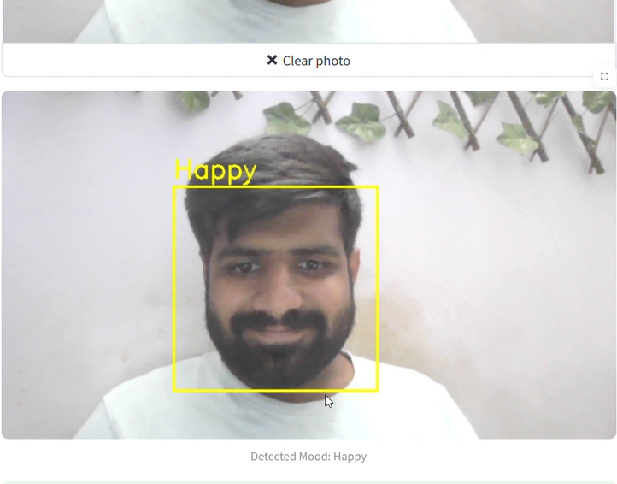

*Fig 4.1 Identify Mood*

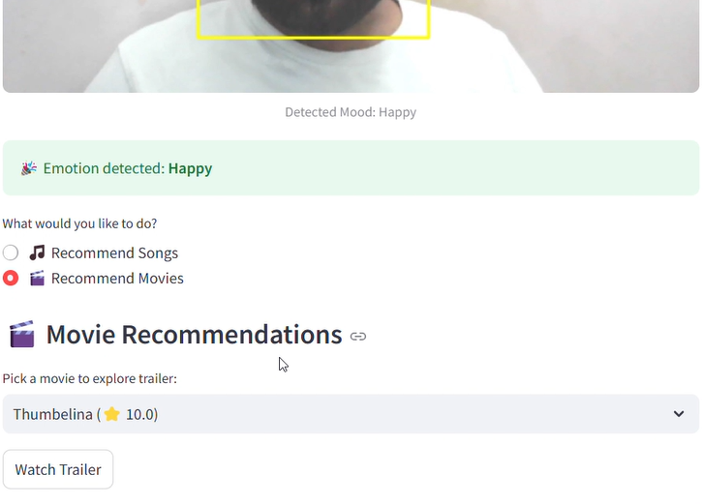

*Fig 4.2 Recommendation Engine* 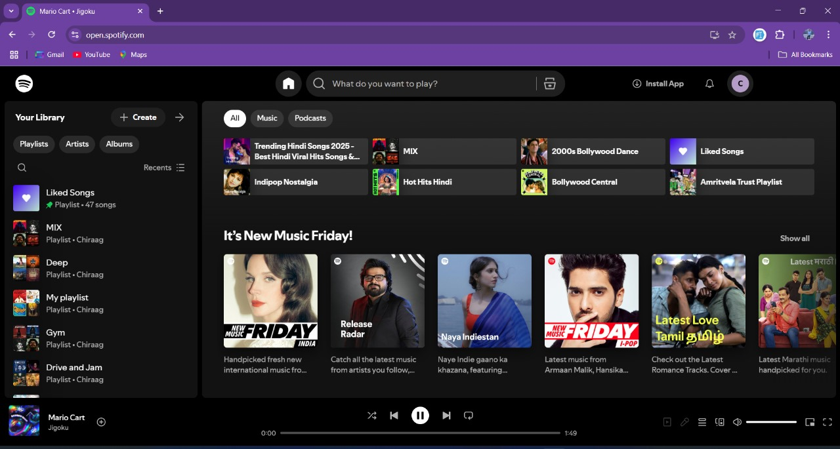

*Fig 4.3 Redirecting to the Music/Movie Platform*

**E. Evaluation**

1. **Emotion Detection:** Achieved 85.2% accuracy with a 0.34 loss. Confusion matrix and classification report showed high precision and recall for all emotions.
2. **Music Recommendation :** Successfully recommended top 5 songs based on detected emotions using K-Means + PCA. Spotify integration worked flawlessly for playback.
3. **Movie Recommendation :** Emotion-to-genre mapping recommended top-rated movies. YouTube trailer links opened correctly.
4. **Sentiment Analysis :** Mapped positive/negative sentiments to emotions accurately using VADER, improving recommendations.
5. **Edge Case Handling :** Correctly handled edge cases like no face detected or no recommendations for Neutral mood.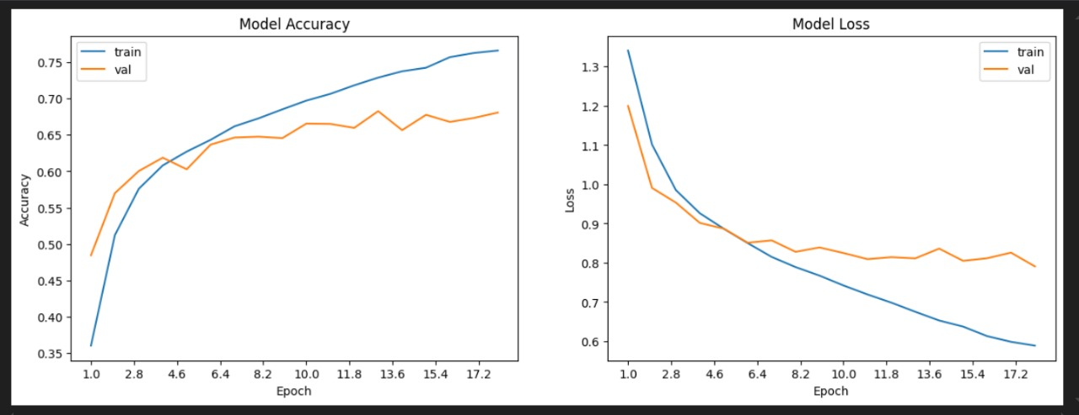

*Fig 4.4: Model Accuracy and Loss*

# V. Conclusion And Future Scope

In this paper, we introduced EmoVerse, a real-time emotion-based recommendation system that enhances user experience by detecting facDocumentryial expressions and providing personalized content. UiAnimation, a CNN model trained on FER-2013, the system claADventuressifies emotions and recommends music, movies, or games accordingly. Unlike traditional recommendation systems, EmoVerse adapts to real-time emotional states and incorporates user feedback for continuous improvement.

For future enhancements, the system can be expanded by integrating multimodal emotion recognition (voice, gestures), optimizing lightweight models for mobile devices, and extending recommendations to books, podcasts, and e-learning platforms. Additionally, implementing transformer-based models can improve emotion detection accuracy, while multi-language support can make the system more accessible.

# References

1. A. Mahadik, V. B. Jagan, S. Milgir, V. Kavathekar, and J. Patel, "Mood Based Music Recommendation System," Proceedings of the Conference, June 2021.
2. P. H. Parmar, "Music Recommendation System Using Facial Expression Recognition," M.Tech. Dissertation, Birla Vishvakarma Mahavidyalaya (Engineering College), Vallabh Vidyanagar, Gujarat, India, July 2020.
3. M. Athavle, D. Mudale, U. Shrivastav, and M. Gupta, "Music Recommendation Based on Face Emotion Recognition," Journal of Information, Electrical & Electronic Engineering, vol. 2, no. 2, pp. 1–11, June 2021, doi: 10.54060/JIEEE/002.02.018.
4. R. W. Lee and A. Namjoshi, "Facial Recognition Music Player Based On Emotions," Multi-Disciplinary Journal, vol. 1, no. 2, pp. 1–11, September 2021.
5. S. M. Florence and M. Uma, "Emotional Detection and Music Recommendation System Based on User Facial Expression," IOP Conference Series: Materials Science and Engineering, vol. 912, no. 6, p. 062007, 2020, doi: 10.1088/1757-899X/912/6/062007.
6. M. Agarwal, P. Saxena, and K. B. Dubey, "Facial Emotion Detector and Music Player System," International Research Journal of Engineering and Technology (IRJET), vol. 8, no. 7, pp. 2478–2482, July 2021.
7. K. S. Chong, "An Emotion-Based Movie Recommendation System Using Convolutional Neural Network," Bachelor's Thesis, Faculty of Information and Communication Technology, Universiti Tunku Abdul Rahman, Kampar, Malaysia, June 2022.
8. P. Wagner, "Face Recognition with Python," July 18, 2012. [Online]. Available: http://www.bytefish.de/pdf/facerec_python.pdf.
9. R. Raut and D. Goel, "Mood-Based Emotional Analysis for Music Recommendation," EasyChair Preprint No. 10377, June 2023. [Online]. Available: https://easychair.org/publications/preprint/B8LQ.
10. Y. K. Bhanushali and Y. S. Patel, "Movie Recommendation System," International Research Journal of Engineering and Technology (IRJET), vol. 8, no. 4, pp. 3220–3223, April 2021. [Online]. Available: https://www.irjet.net/archives/V8/i4/IRJET-V8I41024.pdf
11. N. Mehendale, "Facial Emotion Recognition Using Convolutional Neural Networks (FERC)," SN Applied Sciences, vol. 2, no. 3, p. 446, February 2020, doi: 10.1007/s42452-020-2234-1.
12. M. Parashakthi and S. Savithri, "Facial Emotion Recognition-Based Music Recommendation System," International Journal of Health Sciences, vol. 6, no. S4, pp. 5829–5835, 2022. [Online]. Available: https://doi.org/10.53730/ijhs.v6nS4.9419
13. A. S. Dhavalikar and R. K. Kulkarni, "Face Detection and Facial Expression Recognition System," IEEE, 2014.

**b.Plagiarism Report**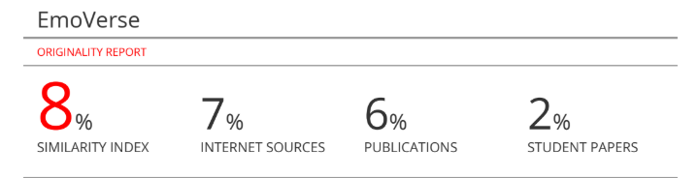

**c.Project Review Sheet 1**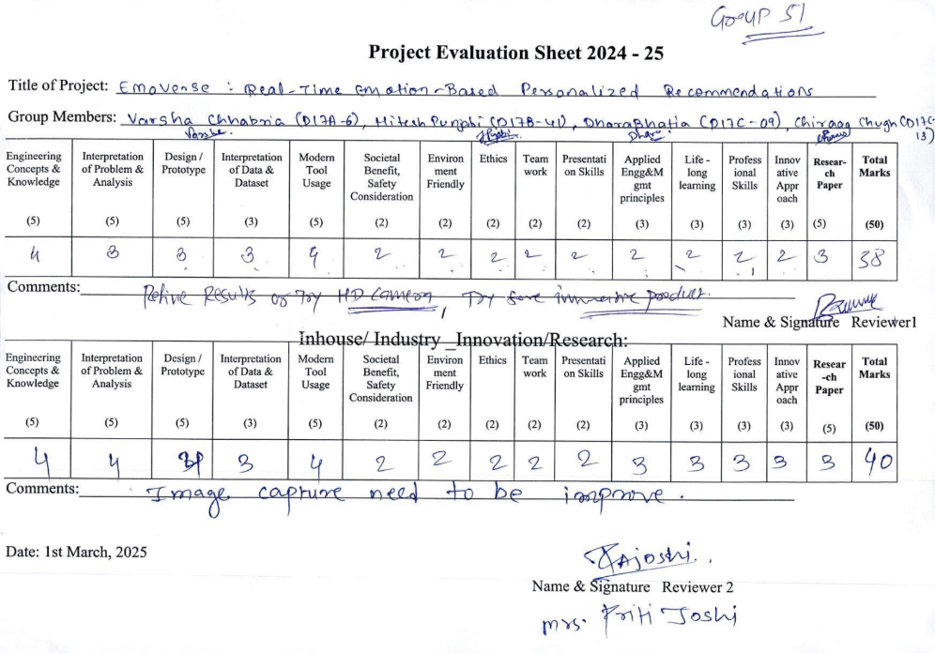

**d.Project Review Sheet 2**

